Aim:
Write a python program to implement BFS.

Objectives:
The objective of the Breadth-First Search (BFS) algorithm is to traverse or search all the nodes of a graph or tree in a level-by-level manner. It starts from a source node, visits all its neighboring nodes first, and then moves to the next level. BFS is widely used to find the shortest path in an unweighted graph, check whether a path exists between two nodes, and ensure that every reachable node is visited exactly once.

Algorithm:
1. Start.
2. Create an empty queue and a visited array.
3. Insert the starting node into the queue and mark it as visited.
4. While the queue is not empty:
Remove the front node from the queue.
Visit (process) the node.
For each unvisited adjacent node:
Mark it as visited.
Insert it into the queue.
5. Repeat until the queue becomes empty.
6. Stop.

Flow chart:
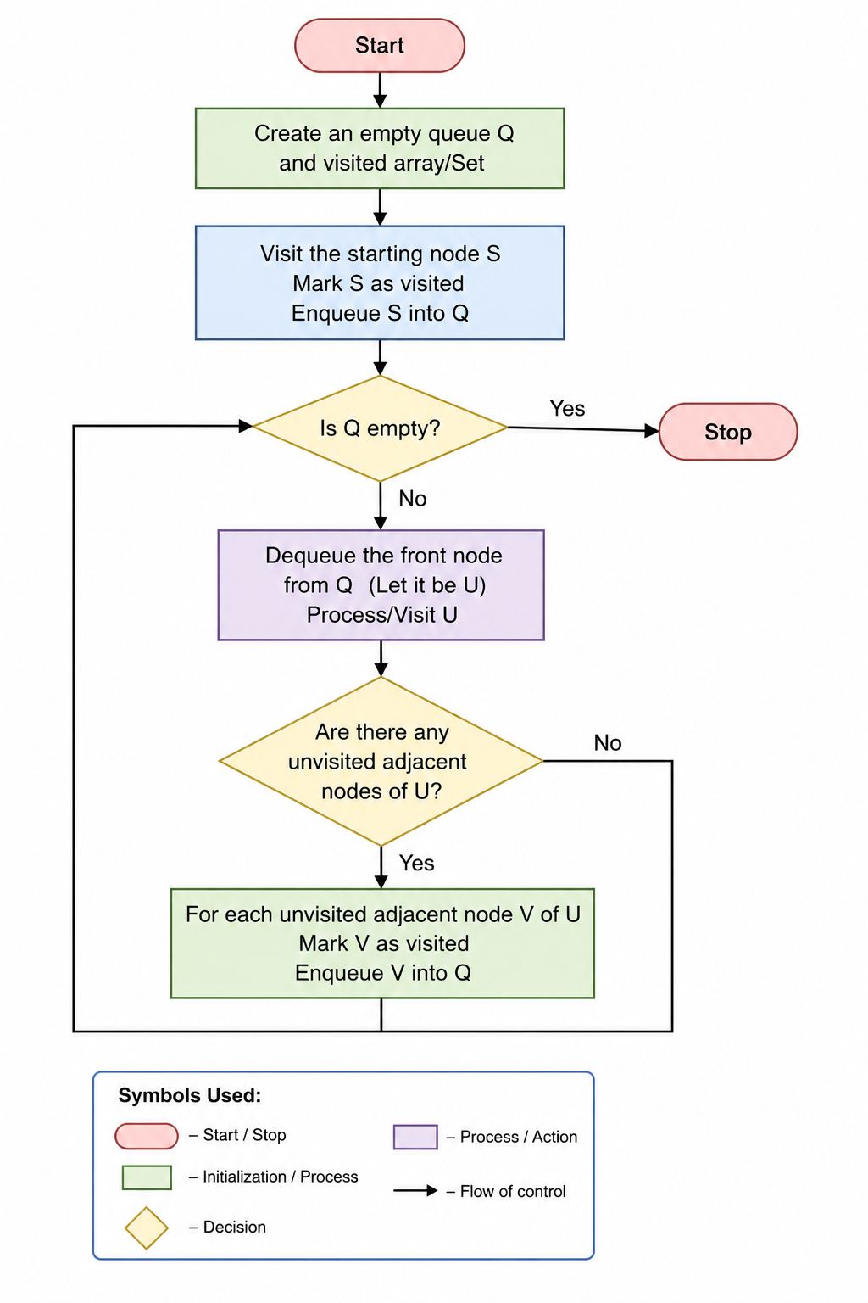

Source Code:
from collections import deque

graph = {
'A': ['B', 'C'],
'B': ['D', 'E'],
'C': ['F'],
'D': [],
'E': [],
'F': []
}

visited = set()
queue = deque()

start = 'A'
visited.add(start)
queue.append(start)

while queue:
node = queue.popleft()
print(node, end=" ")

for neighbor in graph[node]:
if neighbor not in visited:
visited.add(neighbor)
queue.append(neighbor)

Result:
The Breadth-First Search (BFS) algorithm was successfully executed. The graph was traversed in level-by-level order, and all reachable nodes were visited exactly once.
Output:
